Python

Assignment – III

By

Mouli S

Batch - 02

[moulisankar2002@outlook.com](mailto:moulisankar2002@outlook.com)

1.     As discussed in the class today, please Create HTML form having fields – Name, Age, Gender, City and Phone Number.

2.     Using Python Web framework Flask, load in SQL Server Database.

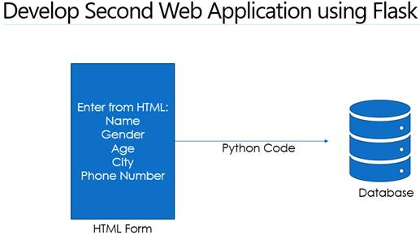

**Code:**

**Python :**

import pyodbc  
from flask import Flask**,** request**,** render_template  
  
app = Flask(__name__)  
  
  
# Define a route for the form page  
@app.route('/')  
def home():  
 return render_template('index.html')  
  
  
# Define a route for the form submission  
@app.route('/submit'**,** methods=['POST'])  
def submit():  
 # Get form data  
 name = request.form['name']  
 age = request.form['age']  
 gender = request.form['gender']  
 city = request.form['city']  
 phone = request.form['phone']  
  
 try:  
 # Establish connection to database  
 connection = pyodbc.connect('Driver={SQL Server};'  
 'Server=Mouli-Sankar;'  
 'Database=Hexaware;'  
 'Trusted_Connection=yes;'  
 )  
  
 # Insert data into database  
 cursor = connection.cursor()  
 query = "INSERT INTO user_info_flask (Name, Age, Gender, City, PhoneNumber) VALUES (?, ?, ?, ?, ?)"  
 values = (name**,** age**,** gender**,** city**,** phone)  
 cursor.execute(query**,** values)  
  
 # Commit changes to database  
 connection.commit()  
  
 # Close connection to database  
 cursor.close()  
 connection.close()  
  
 return "Data successfully submitted to database!"  
  
 except pyodbc.Error as e:  
 print(f"Error inserting data into SQL Server table: {e}")  
 return "An error occurred while submitting the form."  
  
  
if __name__ == '__main__':  
 app.run(debug=True)

**HTML:**

<!DOCTYPE html>  
<html>  
<head>  
 <title>Example Form</title>  
</head>  
<body>  
 <h2>Enter Your Information:</h2>  
 <form method="post" action="/submit">  
 <label for="name">Name:</label>  
 <input type="text" id="name" name="name" required><br><br>  
  
 <label for="age">Age:</label>  
 <input type="number" id="age" name="age" required><br><br>  
  
 <label for="gender">Gender:</label>  
 <input type="text" id="gender" name="gender" required><br><br>  
  
 <label for="city">City:</label>  
 <input type="text" id="city" name="city" required><br><br>  
  
 <label for="phone">Phone:</label>  
 <input type="tel" id="phone" name="phone" required><br><br>  
  
 <input type="submit" value="Submit">  
 </form>  
</body>  
</html>

**sDatabase:**

